Weather Study Guide

- Weather maps help us to FORECAST our weather using our observation skills.
- Study your notes on WARM and COLD front. Know what type of weather each will bring. (foldable) Make sure you know the symbols for each front, too.COLD FRONT: BAD WEATHER RED TRIANGLES on SYMBOL.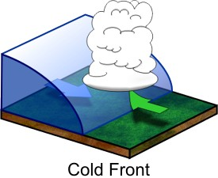
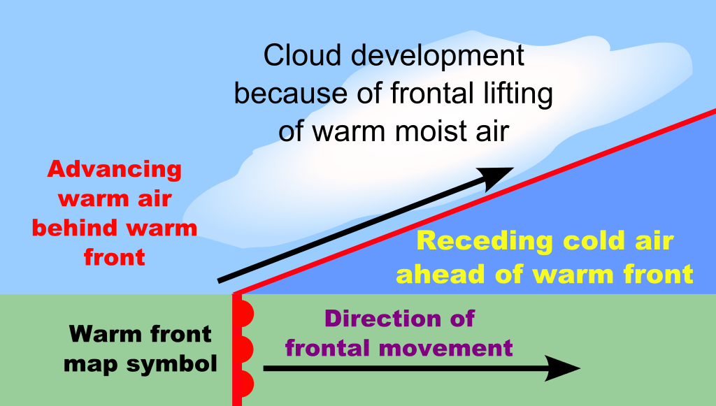WARM FRONT: Steady rain….red semicircles.

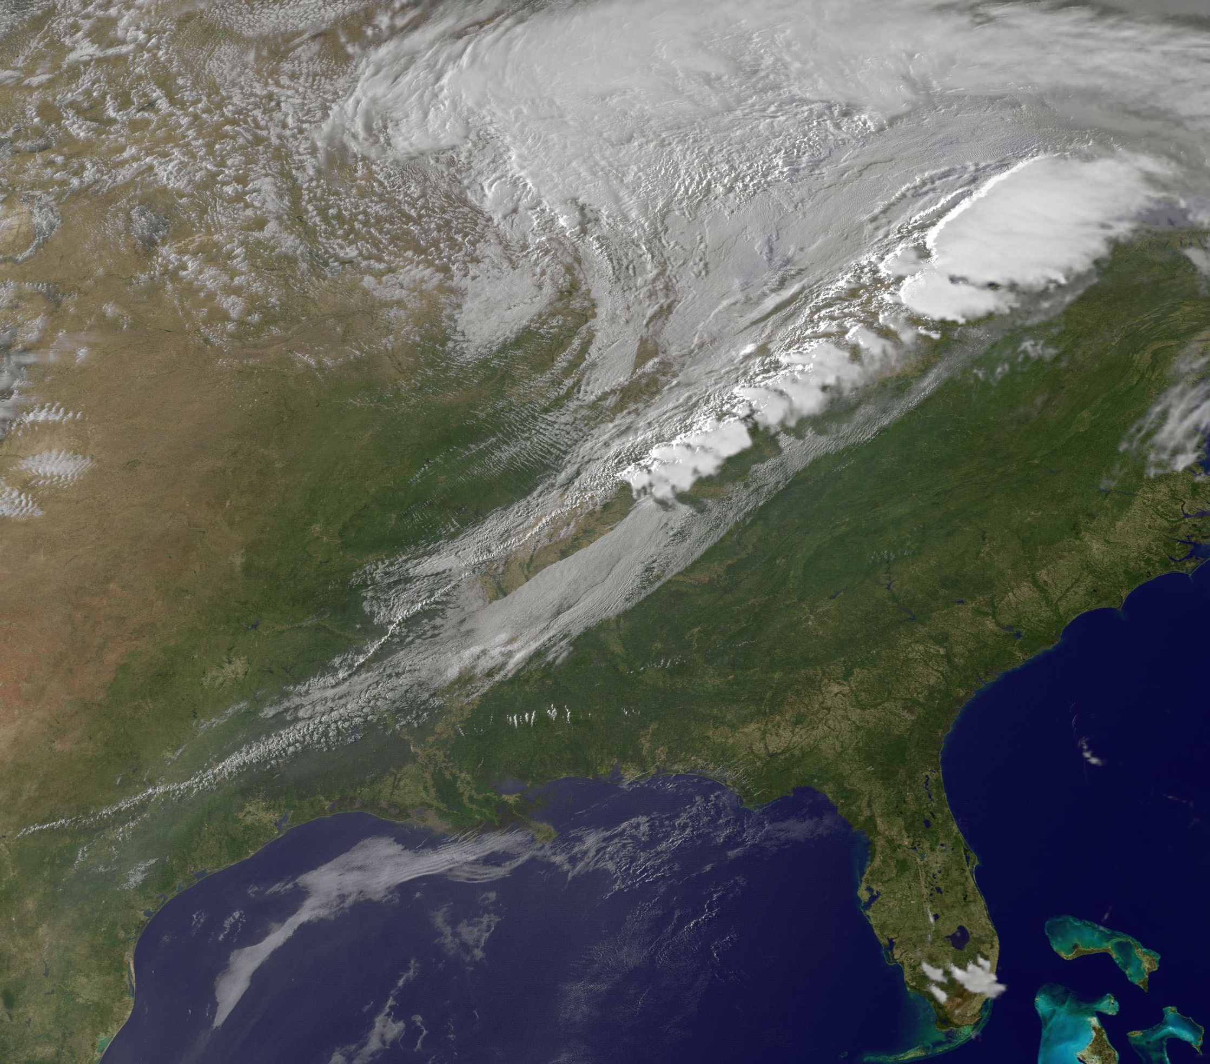
Cold front coming our way…….(old satellite image)
- Weather satellites give us pictures of the movement of clouds

- Weather: the conditions at a specific place and time
- Climate: the AVERAGE weather conditions in an area over a long period of time

- Study your foldable on weather instruments. Be able to match use to a picture of the instrument.

- What is Georgia’s climate like? Be able to describe it. Think of landforms, latitude, etc.
- http://www.georgia.org/competitive-advantages/lifestyle/georgia-climate/

BAROMETER:
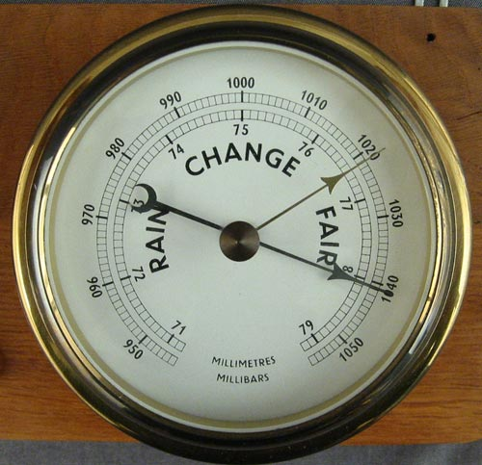
air pressure/barometric pressure

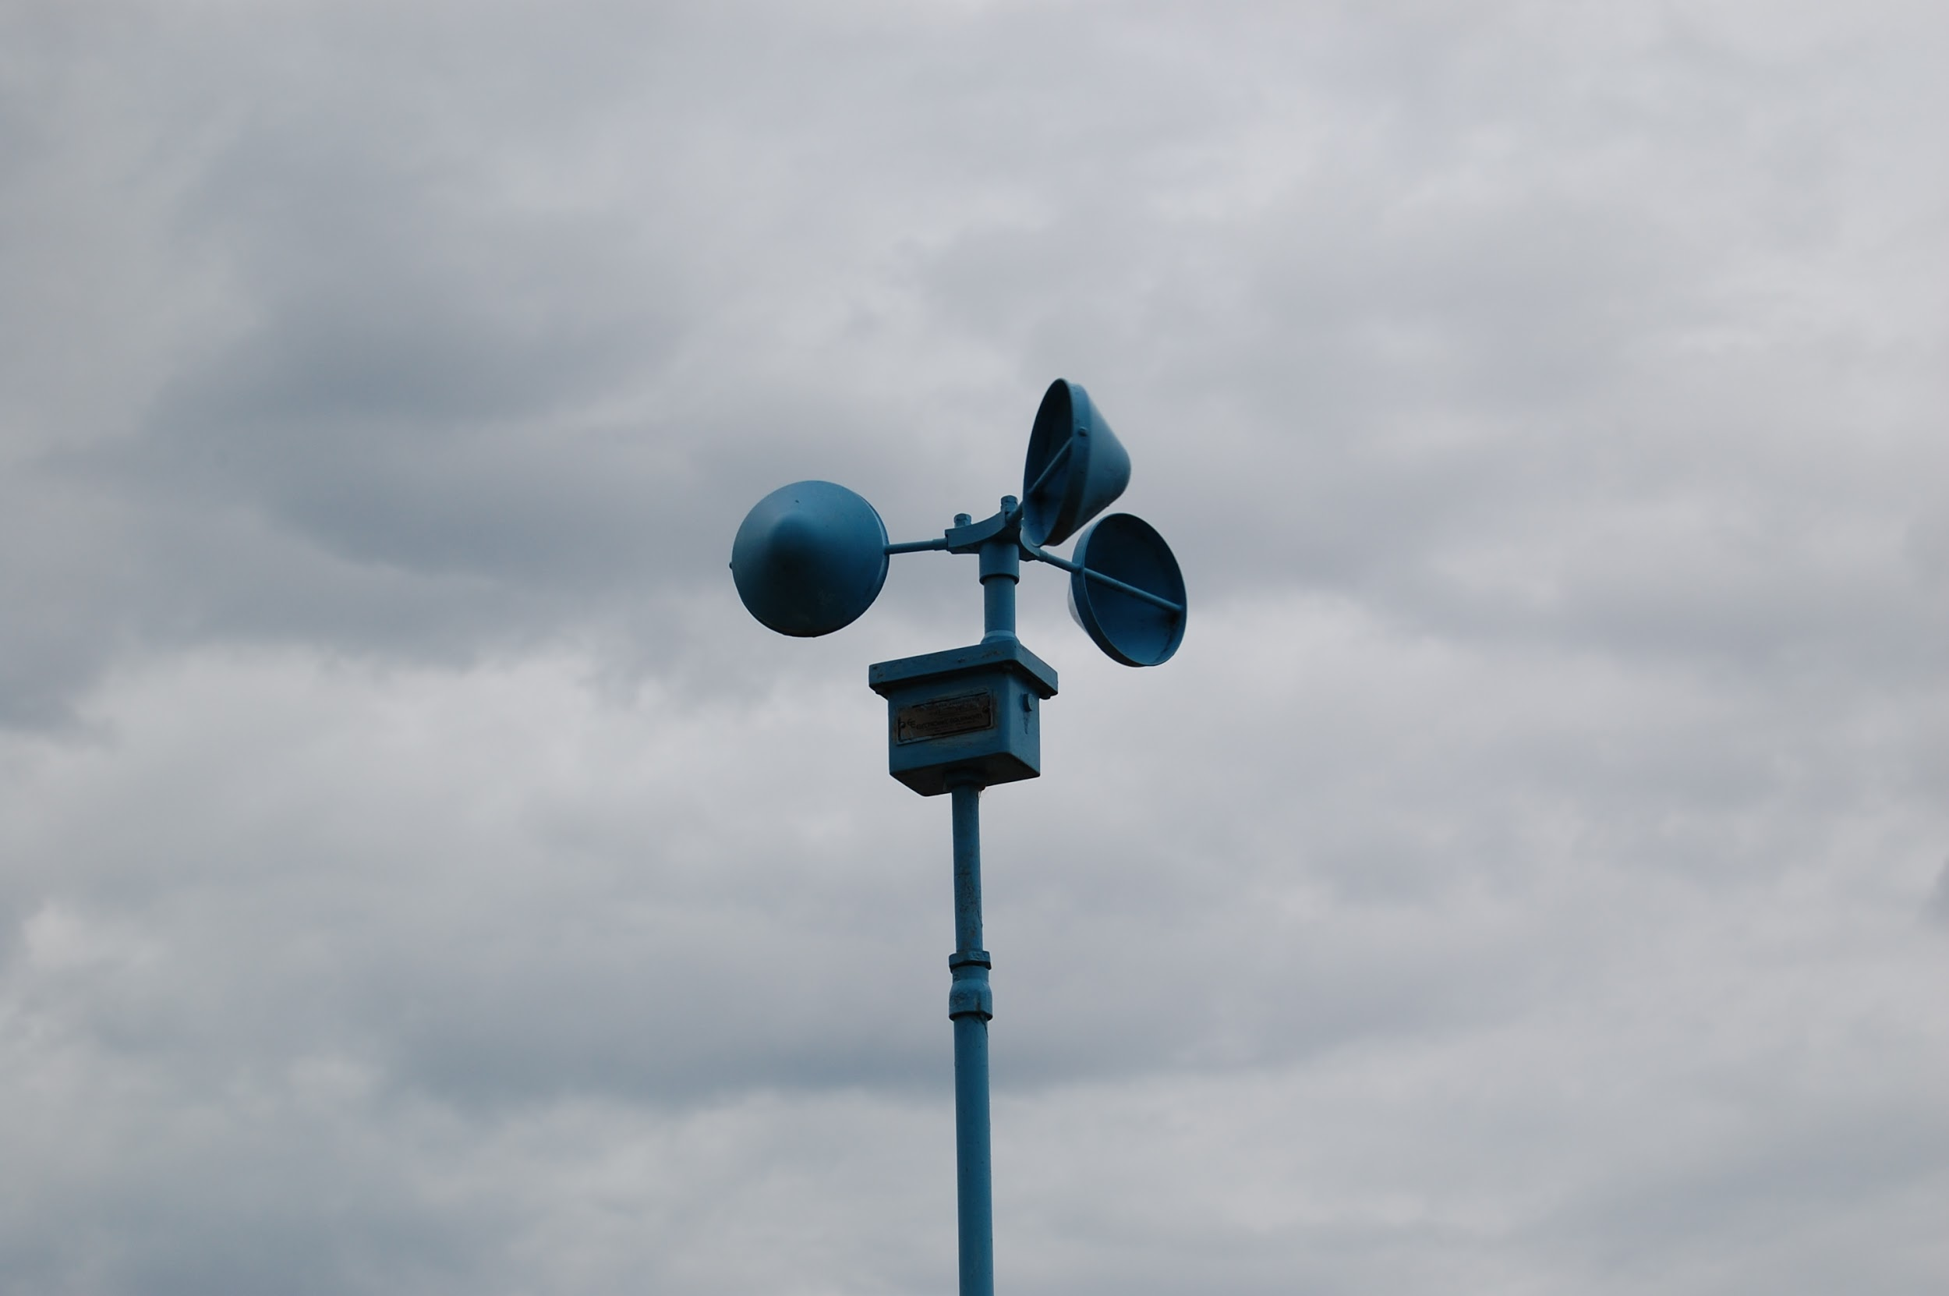
ANEMOMETER: measures wind speed

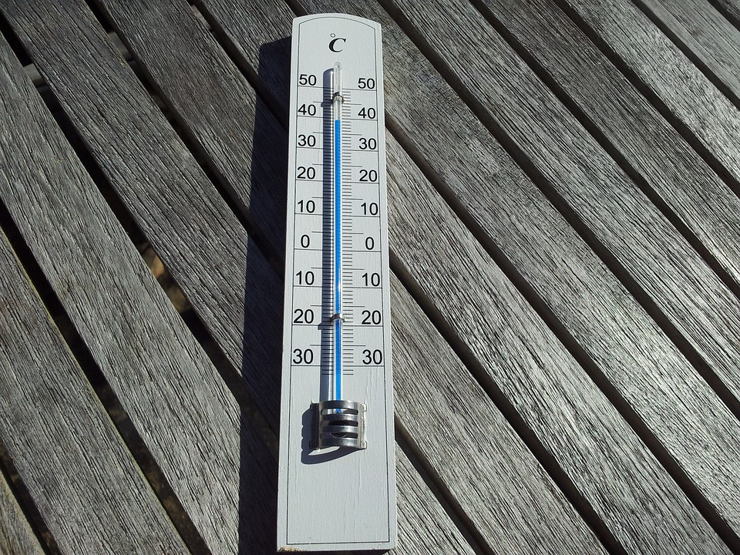Thermometer; Measures temperature
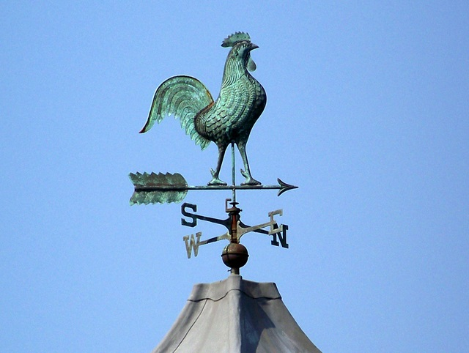
WIND VANE: measures wind direction
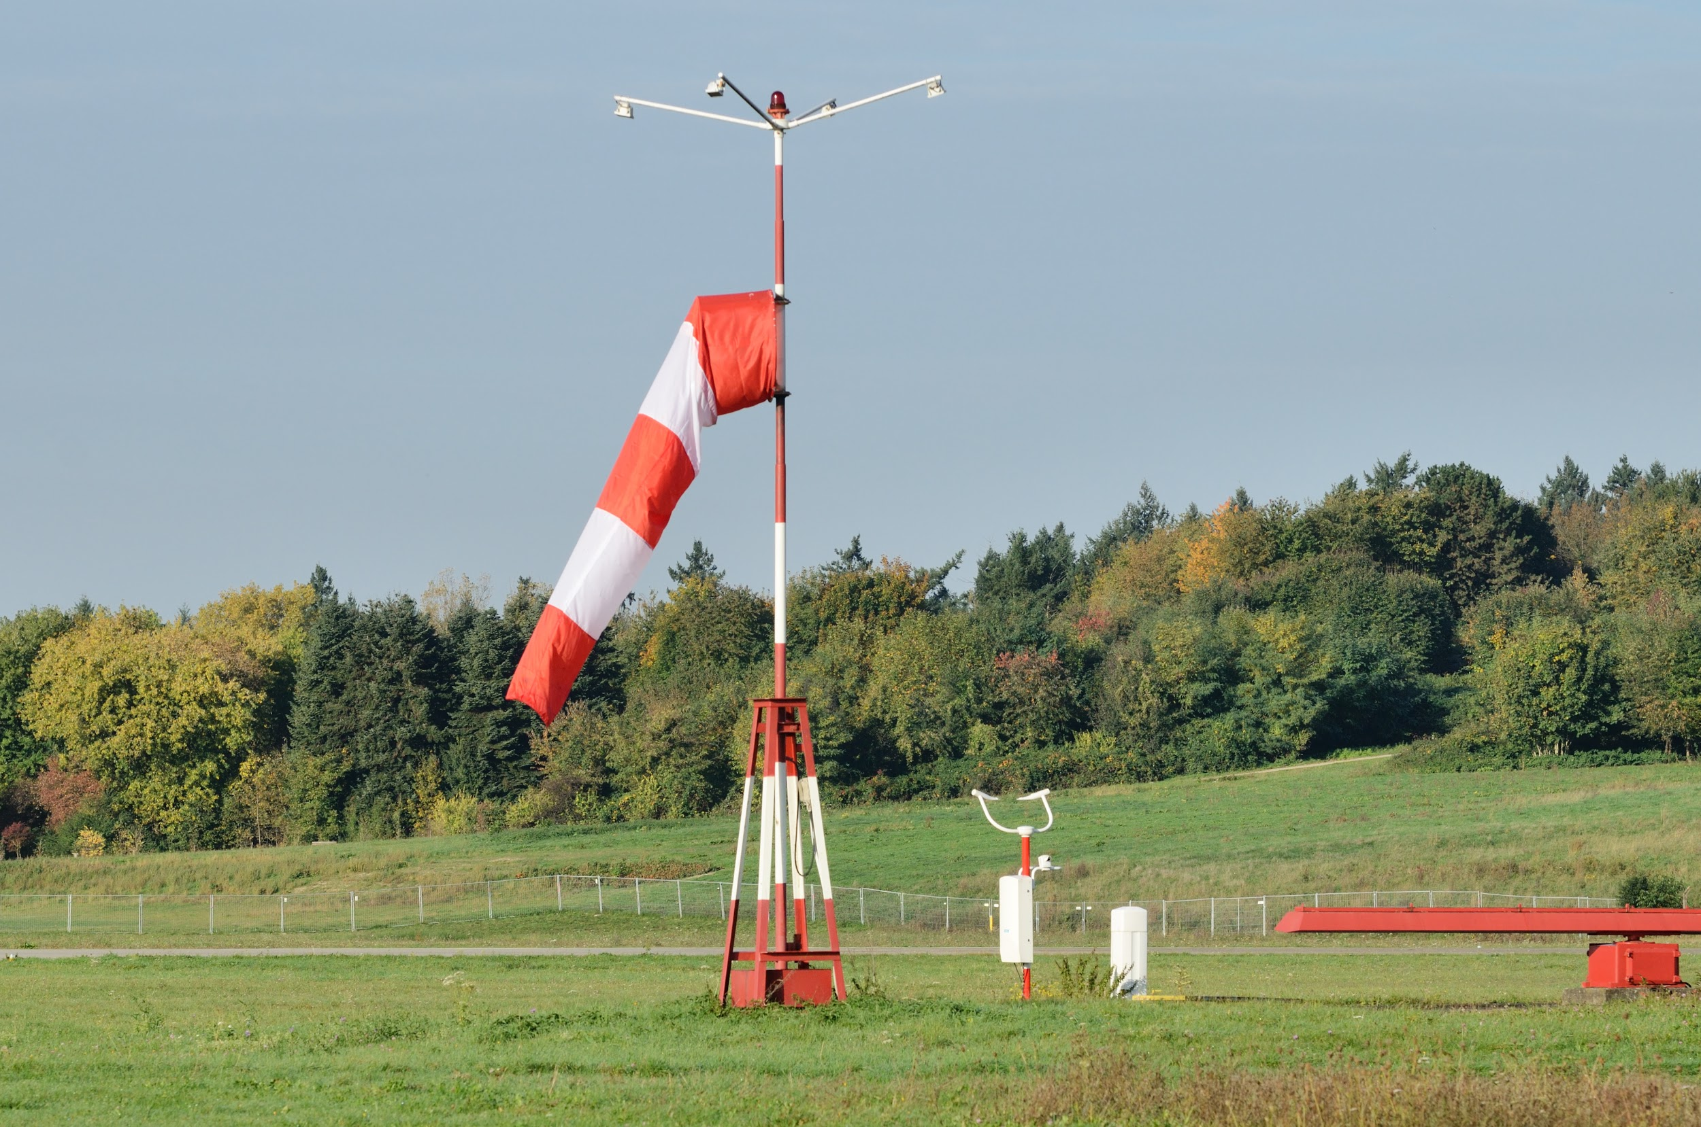
WIND SOCK: measures wind direction

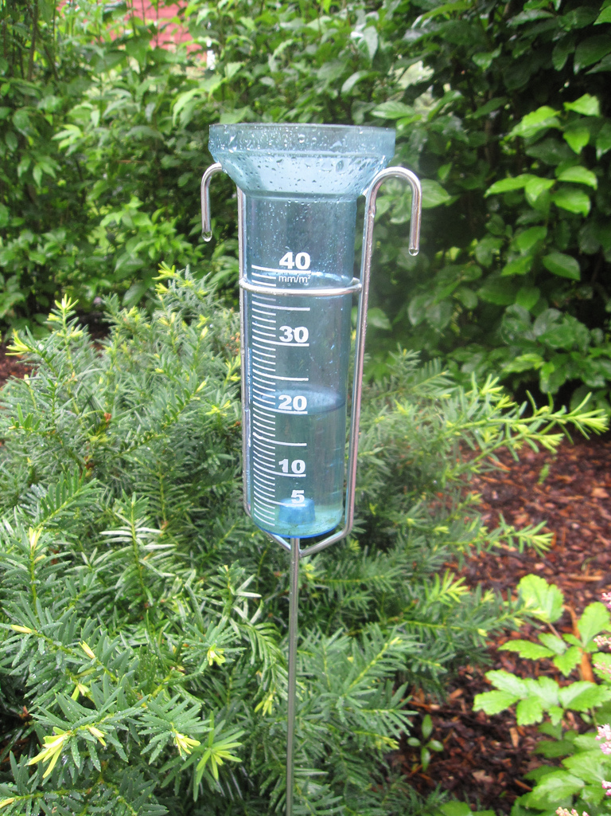
RAIN GAUGE (GAGE): Measures rainfall

