Name _________________________ Date _____________________________

**Forces and Motion**

You move all the time. You walk, run, jump, roll, and fall. So do many objects around you. How do you make something move? You apply a **force**- a **push** or a **pull.**  Once an object is moving, a force can change the way it **moves** How much **matter** is in an object also affects how it **moves**.

[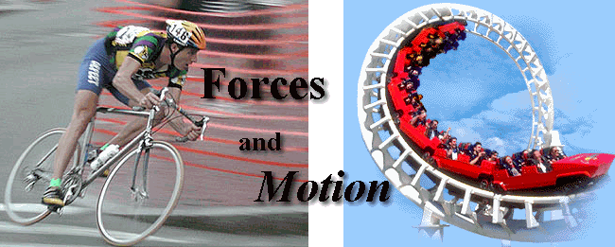](http://www.google.com/url?sa=i&rct=j&q=&esrc=s&frm=1&source=images&cd=&cad=rja&docid=IrAWEHtCEAde5M&tbnid=zkZrDXn401wO7M:&ved=0CAUQjRw&url=http://www.k12tlc.net/content/force.htm&ei=-ncLU6acF8a2kAfgl4FA&bvm=bv.61725948,d.eW0&psig=AFQjCNE4yUtZ6f-1p4uwbYef5r0Yv7aTMw&ust=1393346615416230)

**Forces and Motion**

[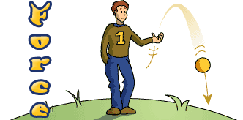](http://www.google.com/url?sa=i&rct=j&q=&esrc=s&frm=1&source=images&cd=&cad=rja&docid=Jbn2RLabtg_SaM&tbnid=COlXxJOd2tcXZM:&ved=0CAUQjRw&url=http://classroom.jc-schools.net/sci-units/force.htm&ei=oXcLU4X2EMvqkQeimYH4AQ&bvm=bv.61725948,d.eW0&psig=AFQjCNE4yUtZ6f-1p4uwbYef5r0Yv7aTMw&ust=1393346615416230)

Let’s say you push a pencil across a desk. You have changed the **position** of the pencil.

* **Position** is the place where an **object is located**.
* **Motion** is **movement, or a change** in an object’s position.
* While you **pushed** the pencil, it was in **motion**.
* A **force** can **change the motion** of a pencil or any object.
* A force is a **push or pull.**
* When you push an object, you **exert a force** toward you.

[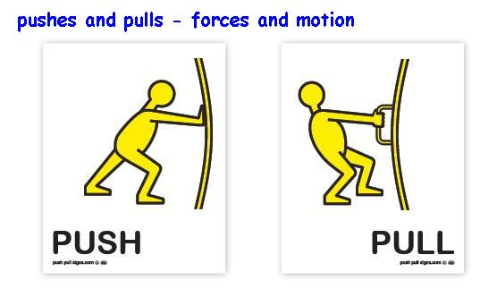](http://www.google.com/url?sa=i&rct=j&q=&esrc=s&frm=1&source=images&cd=&cad=rja&docid=UV_FjVSfCtzLkM&tbnid=kkJmnwUSgJ5wUM:&ved=0CAUQjRw&url=http://www.pushpullsigns.com/pushes-and-pulls-forces-and-motion.html&ei=hnoLU9fOFMuFkQfF3YHQAw&bvm=bv.61725948,d.eW0&psig=AFQjCNFiMOayn3Y3qoHK3BzG-1oy4jsq_g&ust=1393347581353981)

If an object is **not moving**, a force can make it **start moving.**

[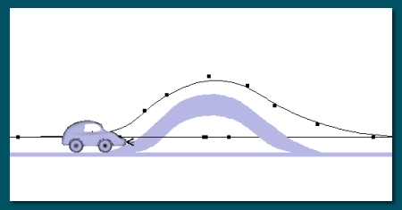](http://www.google.com/url?sa=i&rct=j&q=&esrc=s&frm=1&source=images&cd=&cad=rja&docid=tX5XUXEf6H96TM&tbnid=uPZ0i3dYPjqEHM:&ved=0CAUQjRw&url=http://www.artofillusion.org/docs/cartut/vehicle_tut&ei=LI8LU7nlOsqzkAfGhICgAQ&bvm=bv.61725948,d.eW0&psig=AFQjCNFX1CqcXgeaBLzkyA8UreEmHxYlbg&ust=1393352791149965)

* The object will move in the **same direction** as the force acts.
* **Direction** is the path that a moving object **follows**.
* Look at the soccer ball below. At first, it is not moving. If you kick the ball, you exert a force on it. The ball will start moving in the same direction as you kick.

[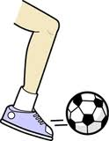](http://www.google.com/url?sa=i&rct=j&q=&esrc=s&frm=1&source=images&cd=&cad=rja&docid=myEQj63sPyAYYM&tbnid=IRFH6N_Whm0-QM:&ved=0CAUQjRw&url=http://patriots-in-motion.wikispaces.com/Forces&ei=N5ELU8rABs-dkAfMlYHYCA&psig=AFQjCNFNCt9HnK9rVYJvW_Me4tpe0dHZJw&ust=1393353250508157)

[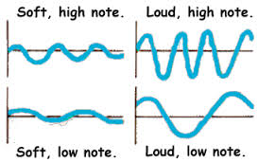](http://www.google.com/url?sa=i&rct=j&q=&esrc=s&frm=1&source=images&cd=&cad=rja&docid=6Bem1AK_KYpk9M&tbnid=Enschk-yo7zj8M:&ved=0CAUQjRw&url=http://library.thinkquest.org/5116/sound.htm&ei=EQ0GU5TPGcyskAe26YGQCw&bvm=bv.61725948,d.aWc&psig=AFQjCNEjwfk1AUPk4WqX11Xzdh2ZB_KH-A&ust=1392991878029969)

If an object is already moving, a force can change the objects **direction**.

[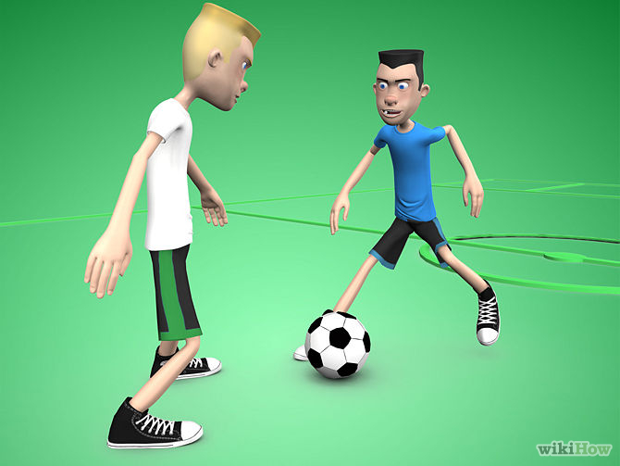](http://www.google.com/url?sa=i&rct=j&q=&esrc=s&frm=1&source=images&cd=&cad=rja&docid=AqoDdimYULt5_M&tbnid=WDmXwJJy_DmgsM:&ved=0CAUQjRw&url=http://www.wikihow.com/Dribble-a-Soccer-Ball-Past-an-Opponent&ei=K5ILU-SNLpDMkAeU74CABw&psig=AFQjCNHbK3sEwauG0M-08NDssemkzfZjzA&ust=1393353622889549)

* Suppose a soccer ball is rolling toward you.
* You can kick it back in the opposite direction, or you can kick it to your left or your right.

A **force** can also change a moving object’s **speed.**

* **Speed** is a measure of **how far** an object moves in a certain amount of **time**.
* A force applied in the **same direction** as the objects motion will make it move **faster.**
* The object will move **farther** in the **same** amount of time.
* A force applied in the **opposite direction** will make the object move more **slowly** or even **stop** moving.

[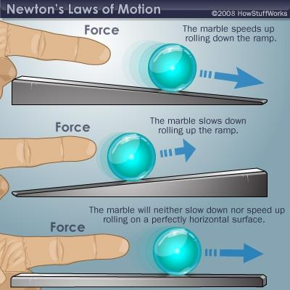](http://www.google.com/url?sa=i&rct=j&q=&esrc=s&frm=1&source=images&cd=&cad=rja&docid=ceiJUnEkopUqCM&tbnid=I2X1YCzUZv-dLM:&ved=0CAUQjRw&url=http://www.studyblue.com/notes/note/n/biomechanics-of-resistance-exercise/deck/5537801&ei=vnsLU6m1A8nYkQfanYCgAw&bvm=bv.61725948,d.eW0&psig=AFQjCNGdmevoIWqPMz1RCkcKSo0YJz_q4w&ust=1393347823677616)

**Mass and Mo** **tion**



The **motion** of an object also depends on the **mass** of the object.

* **Mass** is the amount of matter that makes up an object.
* An object’s mass determines how much motion is **changed by a force**.
* Think about a force pushing on two objects. The one with **less mass** will move **faster and farther**.

Suppose you use a ping-pong paddle to hit both a bowling ball and a ping-pong ball.



The mass of the bowling ball is **much greate**r than the mass of the ping-pong ball. If you hit both ball with the **same force**, the Ping-Pong ball will move **faster**. It will also move **farther**

Now think about different forces **acting** on the **same object**.

* A **large** force will make an object move **faster and farther** than a small force will.
* Suppose you hit a Ping-Pong ball **gently, with a small force**. It will move slowly, and it will only move a short distance. If you hit it hard, with a large force, the ball will move **farther and faster**.

**Gravity and Motion**



**Gravity** is a force that **pulls** things **toward each other.**

* **Earth’s** gravity pulls things toward the **planets center.**
* It **pulls** on all the objects around you, no matter how big or small. As a result, gravity **changes the direction** of an object that moves through the air.
* If you drop or toss a ball, gravity **pulls it down.**

[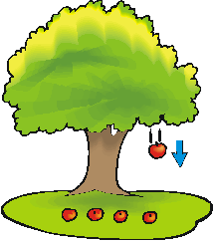](http://www.google.com/url?sa=i&rct=j&q=&esrc=s&frm=1&source=images&cd=&cad=rja&docid=fj9tGfrgGszyCM&tbnid=W5m-tbtmRjIZeM:&ved=0CAUQjRw&url=http://idahoptv.org/dialogue4kids/season12/gravity/facts.cfm&ei=6JkLU4z_JIeT1AHCwoDoAw&psig=AFQjCNFU07Sf2eVlmbe4-VeWVbhKdSIQTw&ust=1393355530614276) [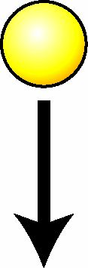](https://www.google.com/url?sa=i&rct=j&q=&esrc=s&frm=1&source=images&cd=&cad=rja&docid=bsBGI6mf48RjuM&tbnid=xnJ24cJKAZ1yRM:&ved=0CAUQjRw&url=https://www.chaostoy.com/cd/html/newton_e.htm&ei=v5oLU-WaLOb80wGZqYDYBA&psig=AFQjCNHRS8-8NXVm7o1upnBbOCIjyjwpwA&ust=1393355788204279)

*What happens if you toss a ball to your friend? If you toss the ball straight out, it might not reach your friend. It might fall to the ground first because of gravity’s pull. You should throw the ball upward and toward your friend. Gravity will pull the ball down in a curved path toward your friend.*

Gravity can also change how **fast an object moves**.

* It **increases** the speed of a falling object.
* Each second, Earth’s gravity causes the object’s speed to increase by about **10 meters per seconds**.
* Earth’s gravity pulls everything you see **downward at the same speed**.
* This is because all ordinary objects are **very small** compared to Earth.

Gravity acts **between all objects** in the universe.

* It acts **without** objects touching one another.
* Earth and the sun are far away from each other. They **never touch**. But gravity helps **hold** Earth in its regular **path** around the sun.

**Did you know**? Water always flows downhill. That is because gravity always pulls it down toward the center of the Earth.

**Discussion Question:** [](http://www.google.com/url?sa=i&rct=j&q=&esrc=s&frm=1&source=images&cd=&cad=rja&docid=0M39VBHMzcbwkM&tbnid=7KcWb6FMB-xdaM:&ved=0CAUQjRw&url=http://library.thinkquest.org/J0112389/newton.htm&ei=jnwLU_TqOoiskAf8soC4Bw&bvm=bv.61725948,d.eW0&psig=AFQjCNGdmevoIWqPMz1RCkcKSo0YJz_q4w&ust=1393347823677616)

A student kicks a soccer ball, and the ball begins moving down the field. While the ball is moving, he kicks it again in the same direction. How does the ball’s motion change as a result of the kicks?

_______________________________________________________________________________________________________________________________________________________________________________________________________________________________________________________________________________________________________________________________________________